SUMMER READING JOURNAL 2026 - ALL STUDENTS
Students should bring this packet, completed, with them to the first full day of school.
English Department Required Summer Reading Journal Notes

Complete the following journal template as you read. You may copy/paste this template into a Word document or Google document and type your responses.
Submit a completed Summer Reading Journal for one book only from your list. Your teacher will expect that you have read all the books, and he or she will announce additional assessments during the first week of school.

SAVE a digital AND handwritten copy of your Summer Reading Journal(s) for your records.
You will be turning in the handwritten copy.

Student’s Name: _____________________________________________________________________
English Course:_______________________________________________________________________
Book Title:____________________________________________________________________________
Author:______________________________________________________________________________
NOTE YOUR GRADE LEVEL THEME & ESSAY TOPIC. This information includes themes and essay topics that will be covered during the year. The essay will be completed in class this coming semester.
Keep your topic in mind as you read and record notes and quotes.
Grade 9 (Journey & Self-discovery): An allegory is a piece of literature in which characters and events represent abstract ideas. Choose a character from Animal Farm and explain how they function as a representation of an idea.
Grade 10 (Catholic Virtues):
- College Prep: The Hobbit
- Honors: The Book Thief
Analyze how the author or a character demonstrates Catholic virtues (faith, hope, charity, fortitude, justice, temperance, prudence), and how these values aid in overcoming obstacles faced in the text.
Grade 11 (The American Voice and Social Justice): How does a major character ultimately find the good in American culture despite the negativity he finds in the troublesome world? Read both books, but choose ONE for the journal.

For AP Language & Composition students: Analyze the ways Temple Grandin, author of Thinking in Pictures, addresses how Autism Spectrum Disorder informs how she thinks and writes and the strategies she employs that enable her to be successful in her life and writing.
Grade 12 (Morality Examined & Dissenting Voices):
- Honors: When I was Puerto Rican
- College Prep: Born a Crime
Identify an issue of how morality has been manipulated and examine how a character challenges this abuse and distortion.
For AP Literature and Composition students only: Analyze how Yaa Gyasi’s tone and style contribute to the development of the theme of multigenerational effects of slavery in Homegoing.
For AP Literature and Composition students only: Analyze how the motif of naming functions in Jhumpa Lahiri’s The Namesake, contributing to the broader theme of the immigrant experience.

CREATE THE MLA WORKS CITED ENTRY
Use the following MLA model to document your book in the space below. Choose the one that best coincides with your source.

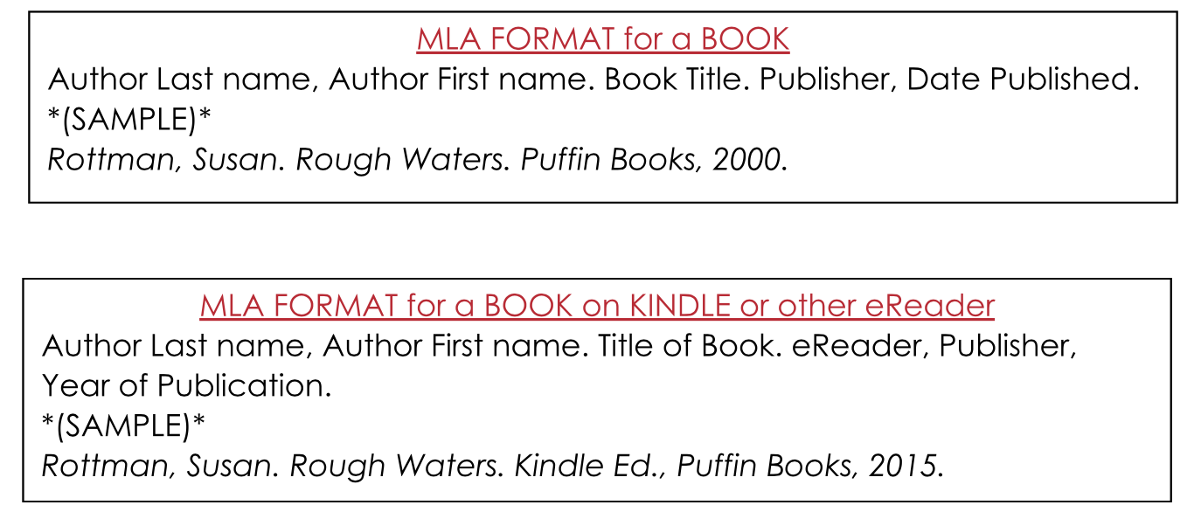
Write your MLA works cited entry here:

___________________________________________________________________________________

“WHY” QUESTIONS
As you read, record 3 questions that begin with “why”. These questions should be open-ended, with many possible answers.
Sample “Why” Question: Why did Simba feel that he had to leave Pride Rock?

Question 1:
_________________________________________________________________________________
_________________________________________________________________________________

Question 2:
_________________________________________________________________________________
_________________________________________________________________________________

Question 3:
_________________________________________________________________________________
_________________________________________________________________________________

RECORD QUOTES TO USE AS EVIDENCE IN YOUR WRITING

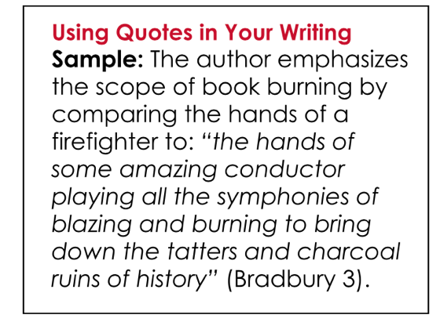
You will need to incorporate quotations from your reading into a short writing piece. Write four (4) quotations from your summer reading book that relate to your theme prompt and that could be used as evidence in a written response to your grade level appropriate question.

Sample Quotation: “Gregg needed to realize that just because Mom and Dad had died, it didn’t mean our family had died. Life went on, and he needed to go on, too, with our family” (Smith 242).

For each of your four quotations, use the proper citation format, and tell how the quotation relates to your theme.

Quotation 1:
_____________________________________________________________________________________________

_____________________________________________________________________________________________

Relation to Theme:
_____________________________________________________________________________________________

_____________________________________________________________________________________________

Quotation 2:
_____________________________________________________________________________________________

_____________________________________________________________________________________________

Relation to theme:
_____________________________________________________________________________________________

_____________________________________________________________________________________________

Quotation 3:
_____________________________________________________________________________________________

_____________________________________________________________________________________________

Relation to theme:
_____________________________________________________________________________________________

_____________________________________________________________________________________________

Quotation 4:
_____________________________________________________________________________________________

_____________________________________________________________________________________________

Relation to theme:
_____________________________________________________________________________________________

____________________________________________________________________________________________________________

CONNECT YOUR READING TO THE THEME (See Page 1 for the themes)
Write a one-paragraph response (in 5-8 sentences) in which you connect your grade-level theme to the plot of your selected book. This will be prewriting for the actual summer reading test, in which your teacher will ask you to expand upon this in an essay written in class. Your four quotes (from the previous section) can be used at that time.

